HOW TO CHANGE A POSTING DATE

To change the posting date on ANY run that was posted to the wrong date you can run the following utility.

Go to N-R (Run custom utility)

Type in util/changper.r

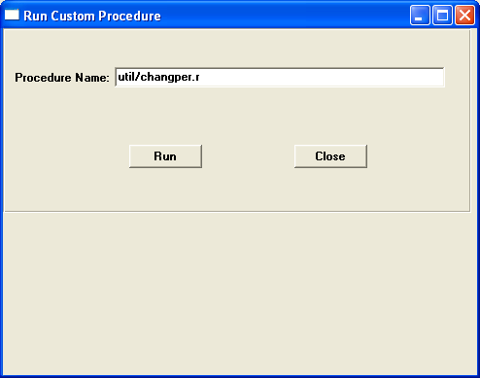

You will then get the following screen:

Type in the run number of the posting register you need to change the date on.

(This can be found on the top of the posting report in the heading)

Tab through the run number and you will see the old post date (existing date) of the run. In the New Date field type in the date you want the posting date changed to. Click start process.

The date is now changed on all history records of this run.

